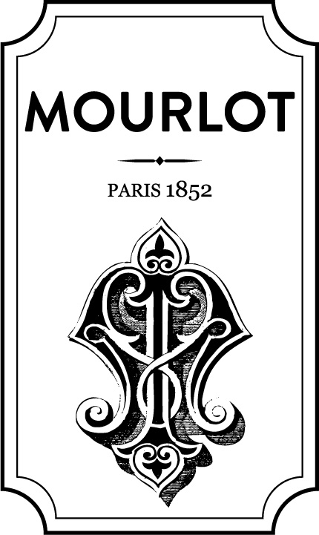TEL +1 212 288 8808

galeriemourlot.com

**GALERIE MOURLOT**

**16 E 79th Street**

**New York, NY 10075**

**Galerie Mourlot Opening Reception for artist Judith Seligson’s Drawing the Line Exhibit**

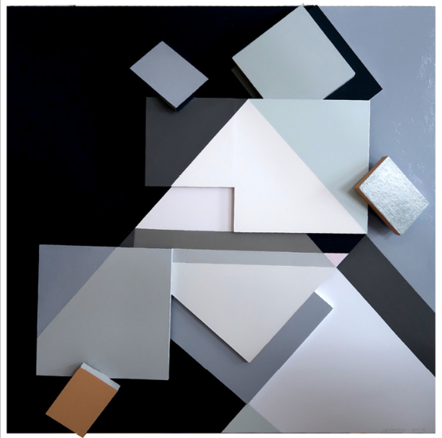

*Fine Tuned*, oil on panels, 20.5” x 20”, 2016

**(Manhattan, NY) October 26, 2016 –** Galerie Mourlot is pleased to be holding the Opening Reception for the American artist Judith Seligson’s *Drawing the Line* exhibit Thursday, November 27th from 6-9pm. The usage of multimedia and geometric shapes in her paintings depicts and demonstrates the common denominator between all objects so as to collapse the space serving to simultaneously conjoin and separate them. In emphasizing the endless possibilities the act of ‘line drawing’ presents, she challenges her audience to question the concept of ‘boundary’ and identify its innately unnatural fixation as the universal root cause of social issues.

*Drawing the Line* is an exhibit of her most recent and publicly unseen paintings, further exploring the potential of her ‘line drawing’ technique to produce an avant-garde experience for the viewer. In superimposing different material objects of the same shape onto a singular plane, she builds a product that explains the process of creating meaning widely considered artistic and takes a theoretical approach to the practice based action of construction. The combination of shapes in her paintings produces socially unidentifiable and abstract objects and generates patterns highlighting their composition.

Judith’s refreshing and bright colors result in an internationally recognized aesthetic liveliness she describes as “a visual melody that pushes your eye around at a certain tempo.” Her work has been featured in the New York Times, reviewed by The Washington Post, and displayed in solo and group exhibits at The Athenaeum and Jane Haslem Galleries in Washington, D.C., Anita Friedman Fine Arts in New York, the Schlesinger Library at Radcliffe, and Art 3 Gallery in Brooklyn. The interdisciplinary approach of her work has received attention from a wide range of fields and she is currently working on a book project entitled *THE GAP: The Synaptic Sign of Modernity*, which focuses on the space between objects in art, science, and literature.

**About Galerie Mourlot**

Galerie Mourlot was founded in 1991 by Eric Mourlot. As the grandson of the director of Atelier Mourlot, the most famous print shop of the 20th century, he grew up learning various printing techniques in the presence and with the aid of artists including Marc Chagall, Alexander Calder, Pablo Picasso, Henri Matisse, and Joan Miró. His surroundings developed into a source of inspiration and he quickly became passionate about the relationships and collaborations that take place between artists, printers, gallerists, and publishers.

Eric opened his first gallery in Boston and in 2005, Galerie Mourlot moved to 16E 79th Street in New York City, where Eric continues to display the works and histories of contemporary and modern master artists, and expose their relationship and connection to the process and art form of lithography. His collection is internationally available to the public in museums, galleries, and art fairs.